Module Name:
Amazon India – Product Search Functional & UI Test Cases
Test Case ID: AMZ_PS_01
Webpage URL: https://www.amazon.in

● Scenario ID: 1a
Scenario: Search product with valid keyword

Test Steps:
- Open https://www.amazon.in
- Click on the Search Bar.
- Enter Wireless Mouse.
- Click the Search icon.

Screenshots:
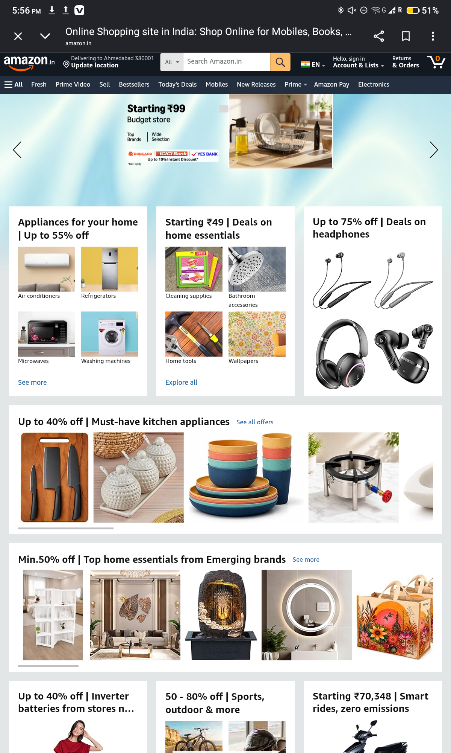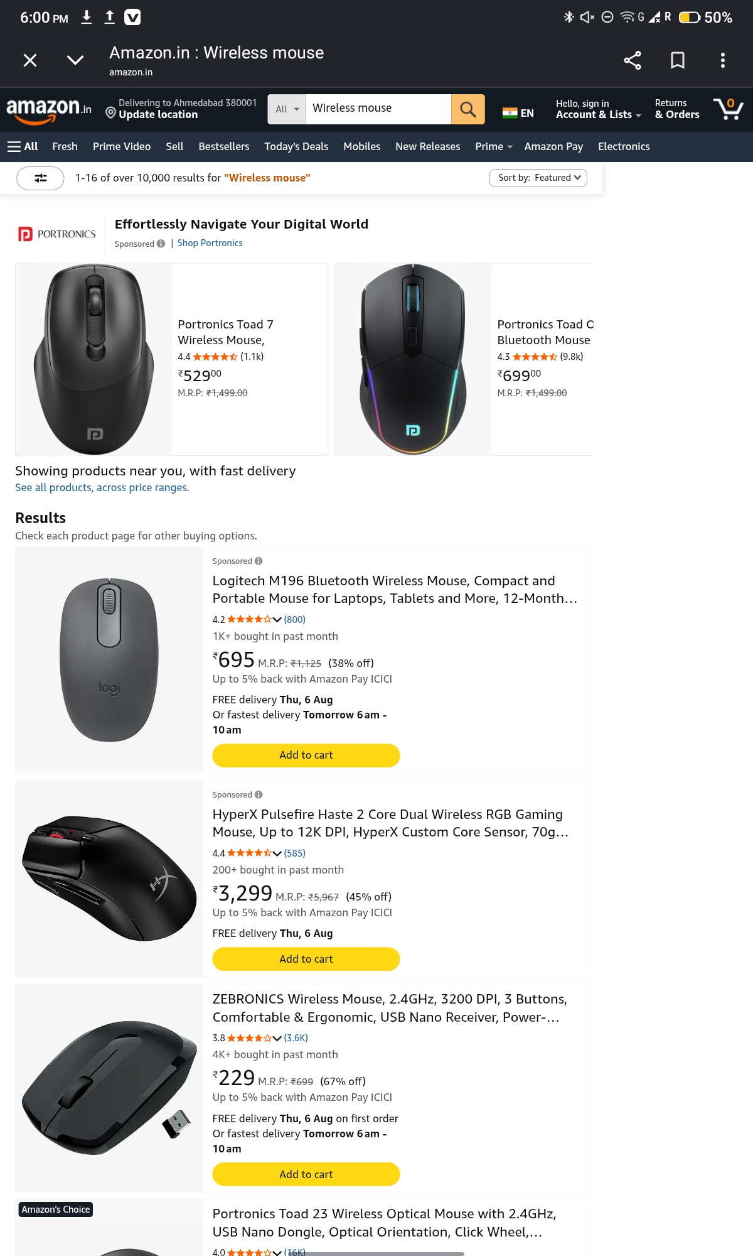● Scenario ID: 1b
Scenario: Search with invalid keyword
Test Steps:
- Open Amazon.
- Enter xyzabc123987.
- Click Search.
Screenshots :
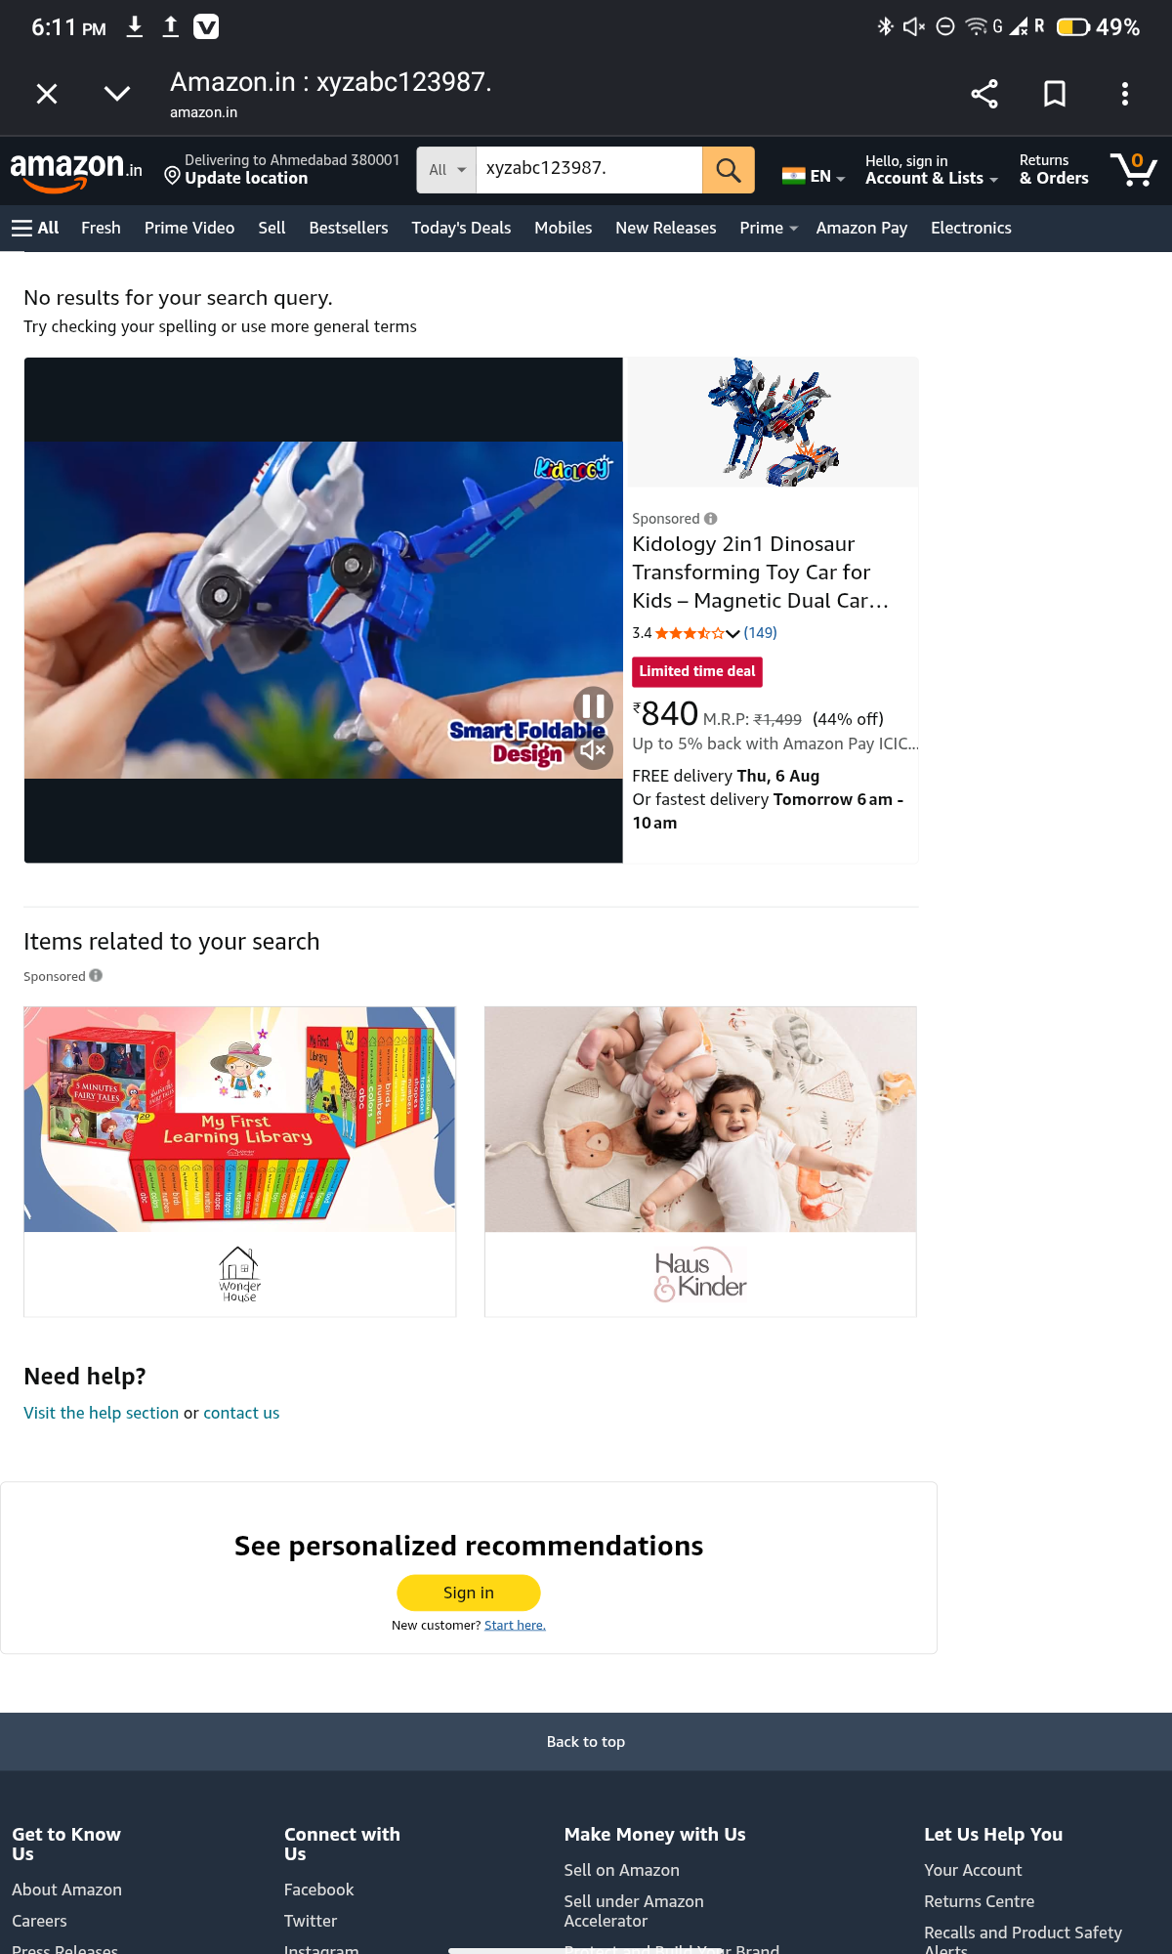● Scenario ID: 1c
Scenario:Search with empty search field
Test Steps:
- Leave search box empty.
- Click Search.
Screenshots:
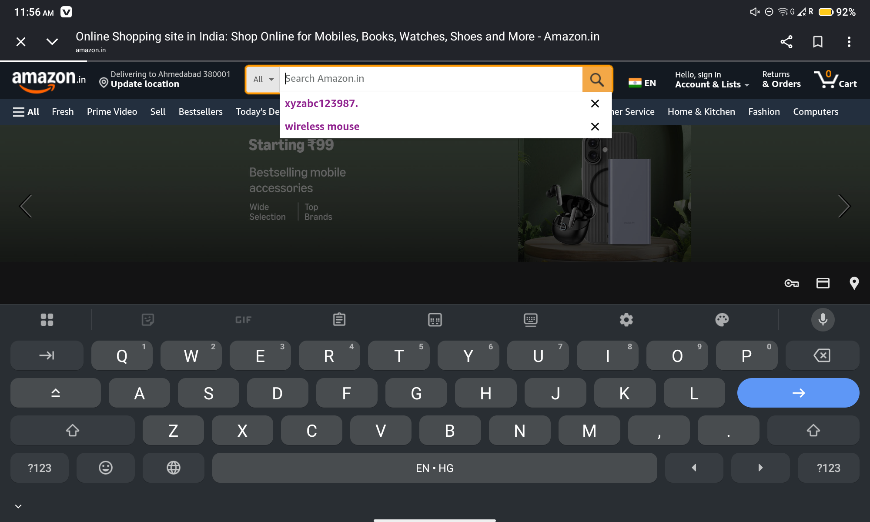It reloads to homepage.

● Scenario ID: 1d
Scenario:Search using special characters
Test Steps:
- Enter @#$%^
- Click Search.
Screenshots:

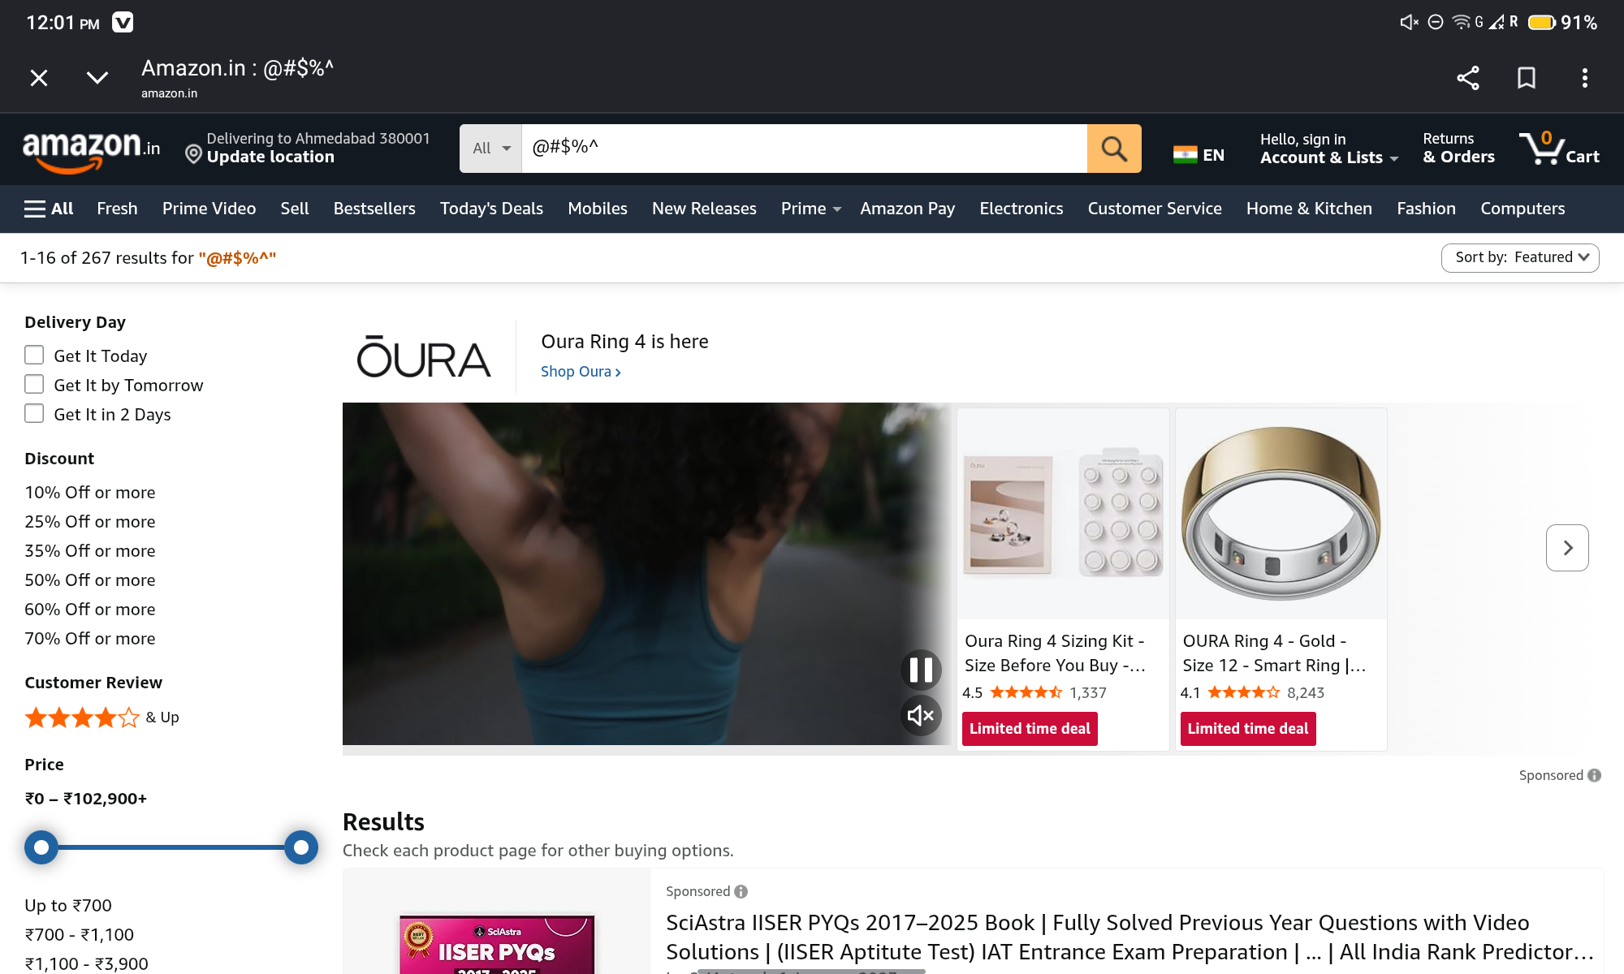

● Scenario ID: 1e
Scenario: Verify Search Suggestions
Test Steps:
- Type Laptop
- Observe suggestions.
Screenshots:
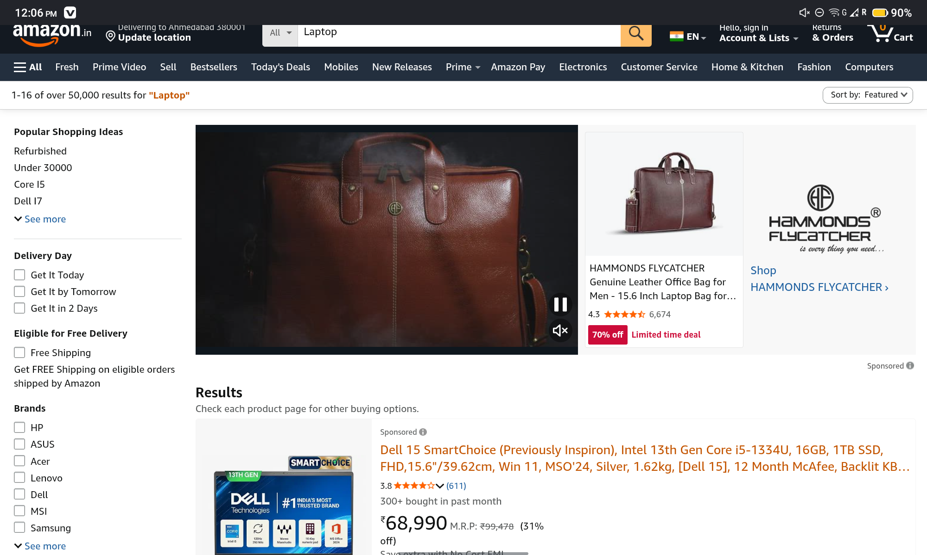

● Scenario ID: 1f
Scenario:Open Product Details
Test Steps
- Search Wireless Mouse
- Click first product.
Screenshots :
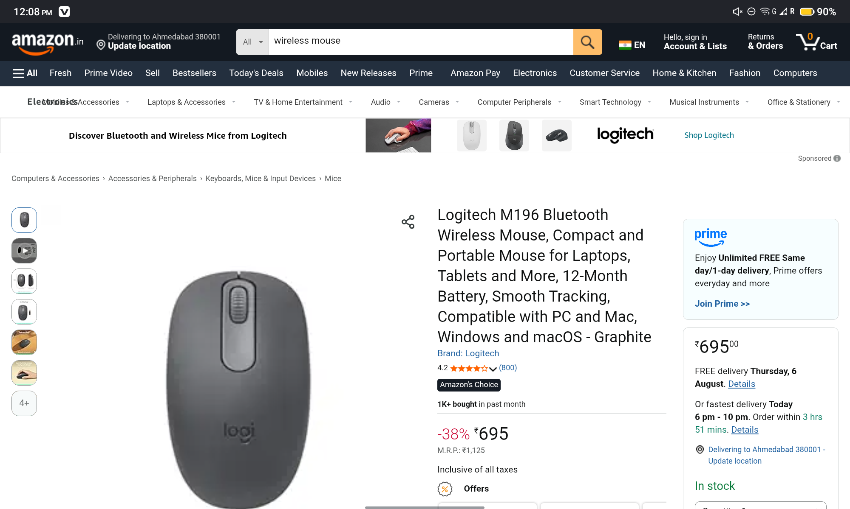

● Scenario ID: 1g
Scenario:Verify Product Images
Test Steps
- Open product page.
- View image gallery.
Screenshots

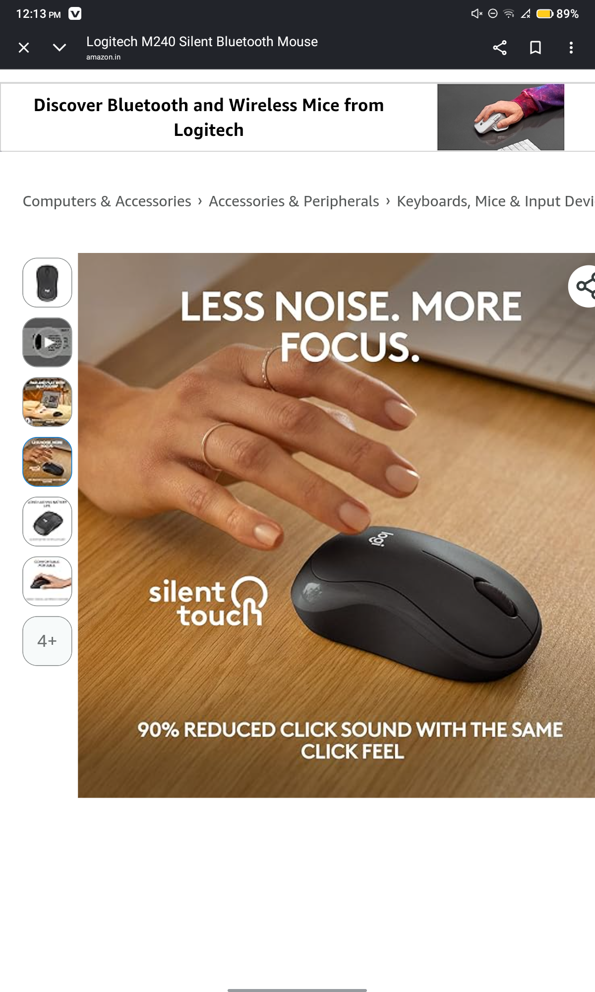
● Scenario ID: 2a
Scenario:Apply Brand Filter
Test Steps
- Search Wireless Mouse.
- Select HP Brand.
Screenshots
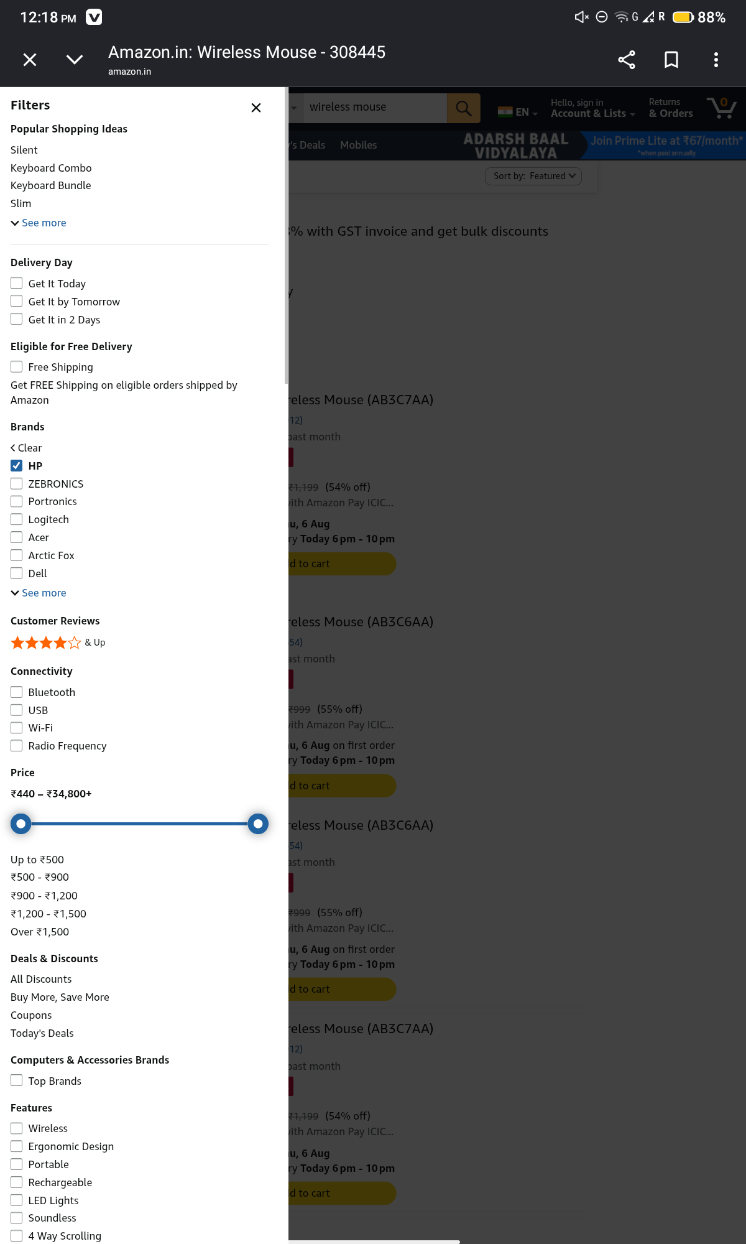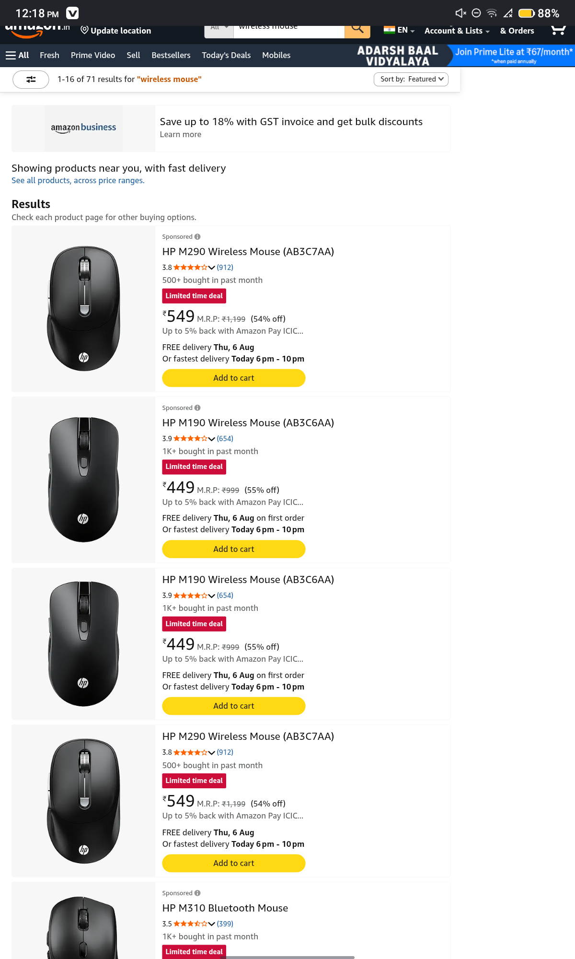

● Scenario ID: 2b
Scenario:Remove Product from Cart
Test Steps
- Open Cart.
- Remove Product.
Screenshots:
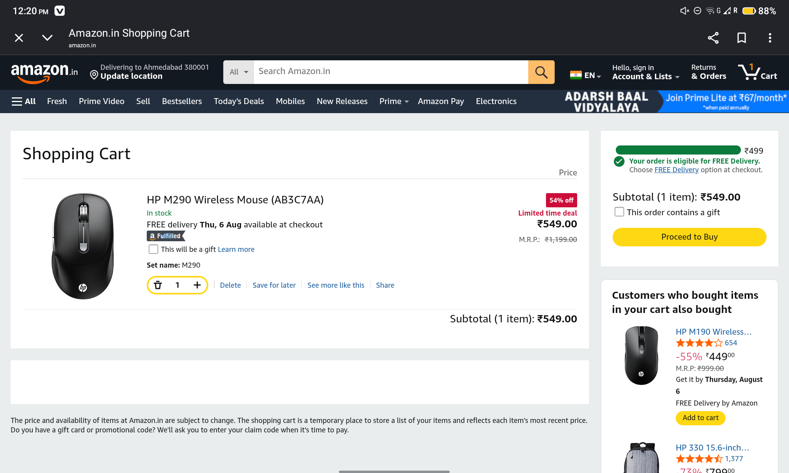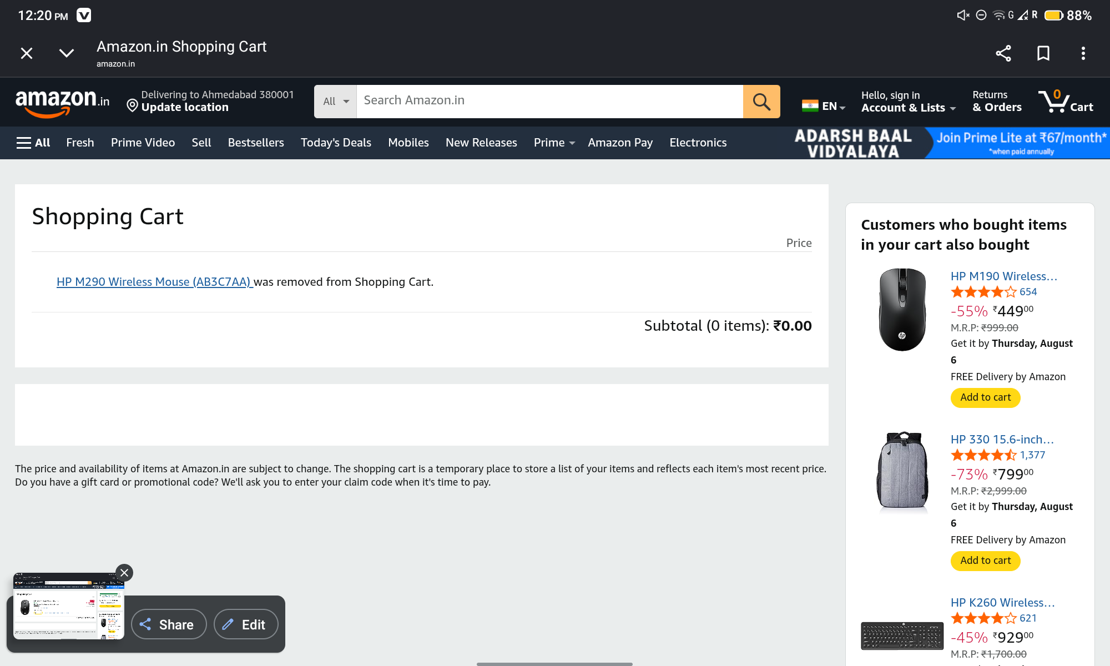

● Scenario ID: 2c
Scenario:Verify Navigation Menu
Test Steps
- Click All Menu.
- Open Electronics.
Screenshots
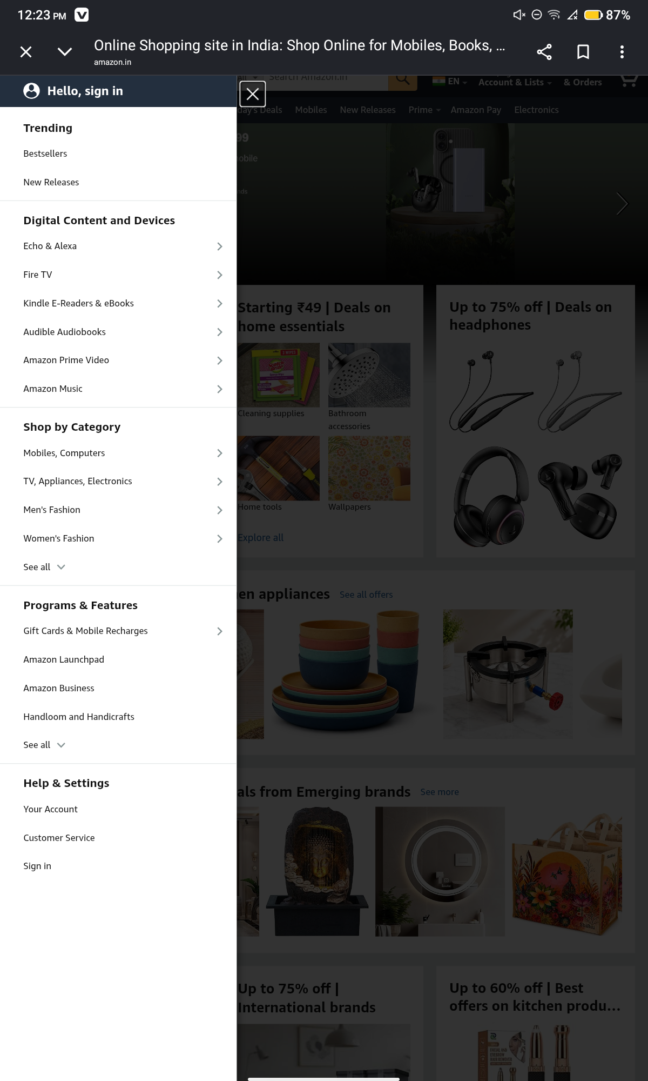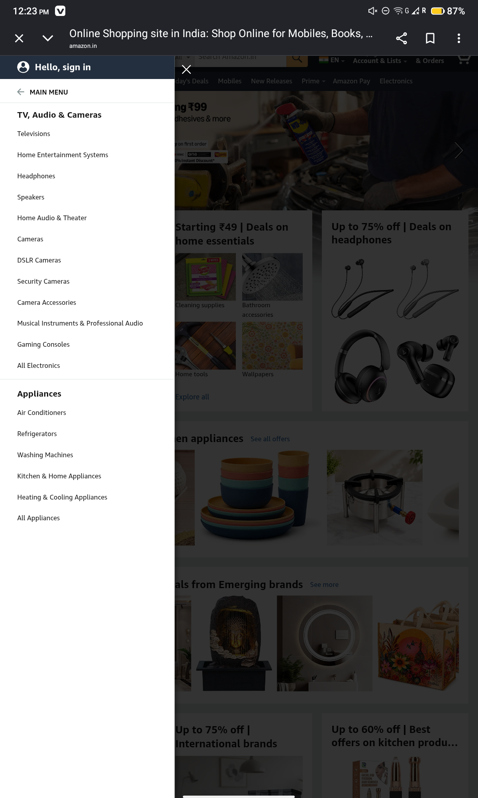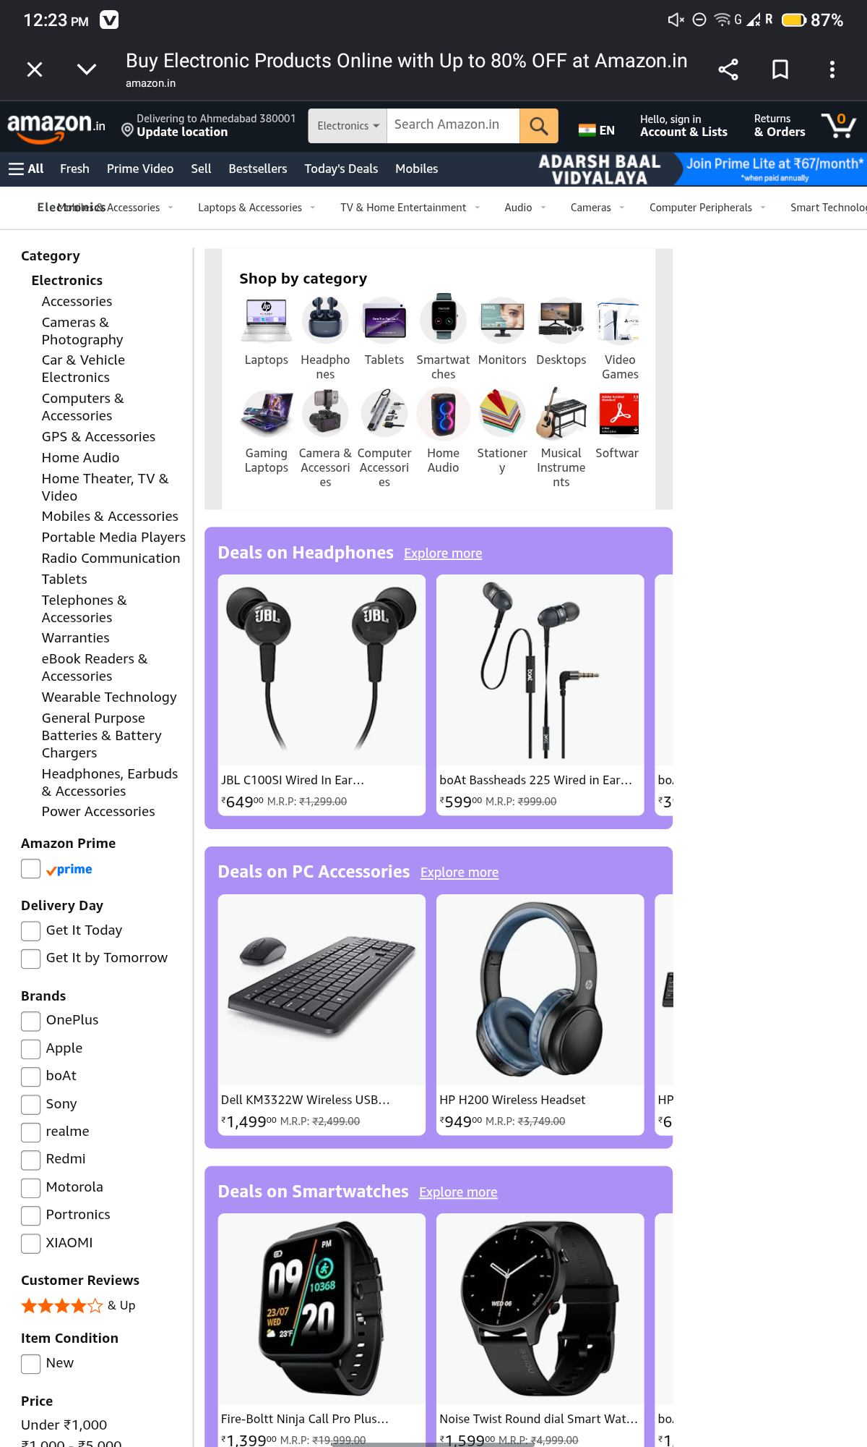

● Scenario ID: 3a
Scenario:Check Buy Now Button
Test Steps
- Open Product.
- Click Buy Now.
Screenshots

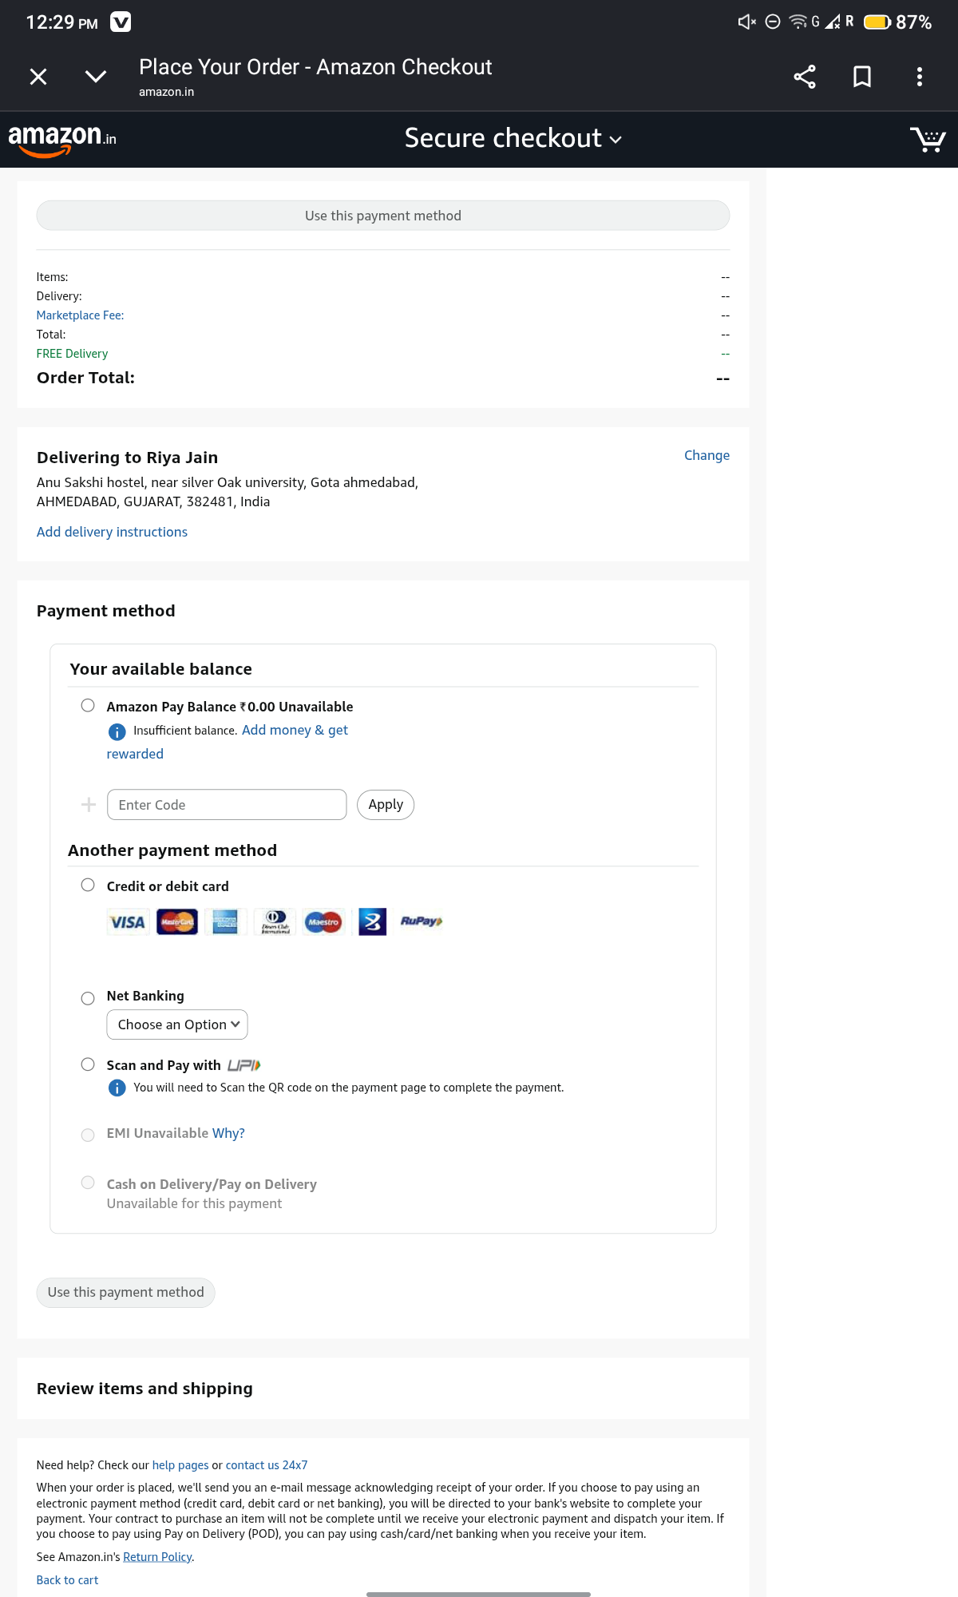
● Scenario ID: 3b
Scenario:Verify Footer Links
Test Steps
- Scroll Down.
- Click About Us.
Screenshots
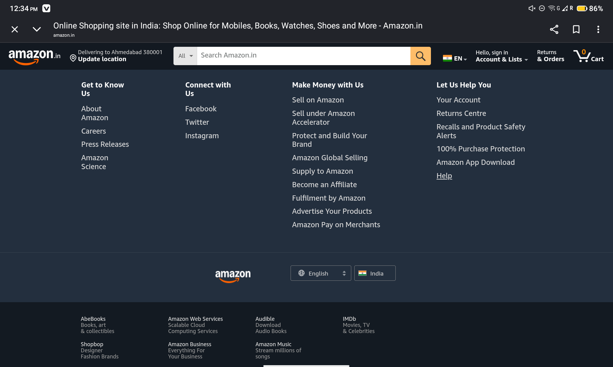

Conclusion and Recommendations
Pass Rate: 100% – Successful Testing
Issues Found:
No critical or major issues were observed during testing. All Product Search test cases executed successfully on the Amazon India website.

Recommendations
- Improve search suggestions by displaying more personalized recommendations.
- Optimize search response time during peak traffic.
- Enhance filter options for easier product discovery.
- Continue regular regression testing after new feature updates.

Bug Reports

Bug Report 1

Field | Description
Bug ID | BUG-01
Title | Search results take longer to load during slow network conditions
Module | Product search
Severity | Low
Steps to reproduce | 1. Open Amazon India.  2. Enable slow network.  3. Search "Wireless Mouse".
Expected result | Search results should load within an acceptable time.
Actual result | Results load with noticeable delay.

Bug Report 2

Field | Description
Bug ID | BUG-02
Title | Some irrelevant products appear for generic search keywords
Module | Product Search
Severity | Low
Steps to reproduce | 1. Open Amazon India  2. Search "Mouse".
Expected result | Only highly relevant mouse products should be displayed
Actual result | A few unrelated accessories also appear in the search results

